2023 Deferred Paper Applied Maths

2023 Deferred Question 1
- 𝐴 and 𝐵 are two 3 × 3 matrices.

- Calculate 𝐴𝐵.
- Verify that 𝐴𝐵 $≠$ 𝐵𝐴.

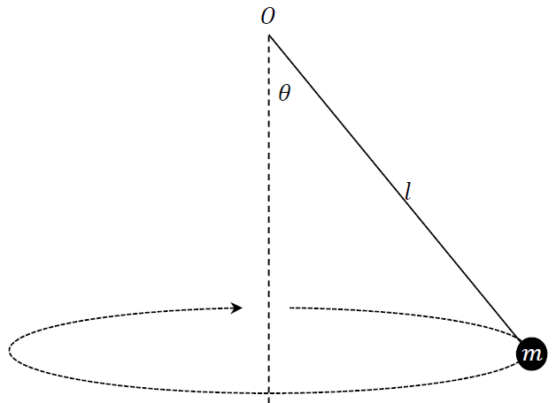
(b) A spherical bob of mass 𝑚 is attached to a light inextensible string of fixed length 𝑙. It is suspended from support point 𝑂.
The string makes an angle 𝜃 with the vertical. The bob moves through a horizontal circle which has its centre on the vertical. The bob has constant linear speed 𝑣.
- Show on a diagram the forces acting on the bob.

- Derive an expression for 𝑣 in terms of 𝑙, 𝜃 and 𝑔, the acceleration due to gravity.

- Derive an expression for 𝑇, the period of rotation of the bob, in terms of 𝑙, 𝜃 and 𝑔.

- Use dimensional analysis to show that the units for the expression you derived in part (iii) are equivalent to the units for period.

2023 Deferred Question 2

(a)
Seven computers, 𝐴, 𝐵, 𝐶, 𝐷, 𝐸, 𝐹 and 𝐺, are part of a computer network. Each computer is connected to one or more of the other computers on the network. The time (in ms) for communication between each of the connected computers is given in the table below.
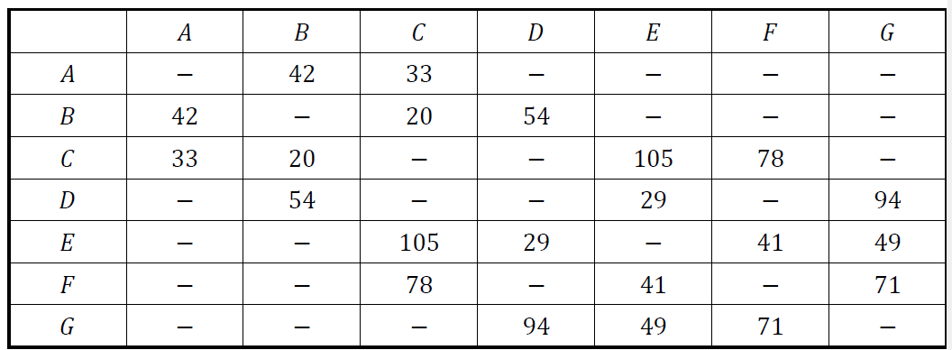

A computer scientist wishes to model this information using a weighted graph, where the nodes represent computers 𝐴 - 𝐺 and the weights of the edges represent the communication times between the connected computers.
- Use the table above to draw a weighted graph to represent the computer network.

- Calculate the shortest time for a message to travel from computer 𝐴 to computer 𝐺. List the computers that the message travelled through, in order. Name the algorithm you used.
Relevant supporting work must be shown.

(b)
In another, larger computer network, a message travels from one computer to another in the network. Each time a message travels from one computer to the next the number of errors in the message, 𝐸, increases by 15%. However 𝐶 errors are corrected each time the message travels. The number of computers the message travels to is counted using the number 𝑛.

A message starts at computer 𝑛 = 0 and travels on a linear path through the computer network.
𝐸, the number of errors in the message, may be modelled by the difference equation:
E_{n+1} = 1.15E_{n} - C

where 𝑛 ≥ 0, 𝑛 ∈ ℤ.

There are 101 errors in the message when it leaves computer 0, i.e. 𝐸₀ =101.
- Solve this difference equation to find an expression for 𝐸_{n} in terms of 𝑛 and 𝐶.

- It is found that the message contains zero errors after it reaches the 21st computer, i.e. 𝐸21 = 0.
Calculate the value of 𝐶 to the nearest whole number.

- 𝐸 may also be modelled using a differential equation. Write a differential equation for $\frac{dE}{dn}$, the rate of change of 𝐸 with respect to 𝑛, in terms of 𝐸 and 𝐶.

2023 Deferred Question 3

In an economic model, the gross national income 𝐺 of a country, consists of three separate contributions:

𝐺 = 𝑃 + 𝐼 + 𝑆

where 𝑃 represents private spending by citizens, 𝐼 represents investment in the economy, and 𝑆 represents government spending.
𝐺 can be modelled using a difference equation, where 𝑃 and 𝐼 change each year 𝑛 and where 𝑆 is assumed to be constant. That is:
𝐺_{n} = 𝑃_{n} + 𝐼_{n} + 𝑆

In any year, 𝑃 is proportional to the value of 𝐺 for the previous year. That is:

𝑃_{n+1} = 𝑎𝐺_{n}
where 𝑛 ≥ 0, 𝑛 ∈ ℤ and $α=\frac{15}{16}$

In any year, 𝐼 is proportional to the change in the value of 𝑃 between that year and the previous one. That is:

I_{n+1} = b(𝑃_{n+1} - P_{n})
where 𝑛 ≥ 0, 𝑛 ∈ ℤ and $b=\frac{3}{5}$

- Use this information to form a second‐order inhomogeneous difference equation for 𝐺 and express it in the form:
𝐺_{n+2} + cG_{n+1} + dG_{n} = 𝑆

for the constants 𝑐, 𝑑 which are to be determined.
Calculate the values for 𝑐 and 𝑑.

- Assuming the government spends no money (i.e. assuming 𝑆 = 0 euro), 𝐺 can be expressed by the second‐order homogeneous difference equation:

𝐺_{n+2} + cG_{n+1} + dG_{n} = 0

Using 𝐺₀ = 840 and 𝐺₁ =820 in billions of euros, solve this difference equation to find an expression for 𝐺n in terms of 𝑛.
Calculate 𝐺₆ to the nearest billion euros.

- Assuming the government spends 40 billion euros each year (i.e. assuming 𝑆 = 40 in billions of euros), 𝐺 can be expressed by the second‐order inhomogeneous difference equation:
𝐺_{n+2} + cG_{n+1} + dG_{n} = 40

Again using 𝐺₀ = 840 and 𝐺₁ =820 in billions of euros, solve this difference equation to find an expression for 𝐺_{n} in terms of 𝑛.
Again calculate 𝐺₆ to the nearest billion euros.

2023 Deferred Question 4

In 1838 the Belgian mathematician Pierre François Verhulst published a differential equation to model rate of change of population 𝑃 with respect to time 𝑡:

$$\frac{dP}{dt}=rP(1-\frac{P}{K})$$

where 𝑟 and 𝐾 are constants for a given population.

For a certain species of insect in an environment it is known that the population can increase by up to 8% per week, i.e. 𝑟 = 0.08.
At 𝑡 = 0 weeks there are 20 insects in the population.
When the population 𝑃 is small relative to 𝐾, the ratio $\frac{P}{K}$ is also small and Verhulst’s model can be approximated by the simplified differential equation:

$$\frac{dP}{dt}=rP$$

- Solve this simplified differential equation to find an expression for 𝑃 in terms of 𝑡.
- Calculate 𝑃 to the nearest whole number when 𝑡 = 12 weeks.
- Explain why this approximation of Verhulst’s model is not practical for predicting the long‐term behaviour of the population of insects.
- Solve the differential equation for Verhulst’s model: $$\frac{dP}{dt}=rP(1-\frac{P}{K})$$

to find an expression that relates 𝑃, 𝐾 and 𝑡.

Note that $\frac{1}{y(x-y)}=\frac{1}{x}(\frac{1}{y}+\frac{1}{x-y})$

- 𝑃 = 39 insects when 𝑡 = 12 weeks. Calculate the value of 𝐾 to the nearest whole number.

- Explain the significance of 𝐾 in the Verhulst model.

2023 Deferred Question 5

- A ball is thrown vertically upwards from the edge of a building that is 24.5 m high.
The ball reaches its maximum height 2 s after it is thrown.
Using a model that neglects the effects of air resistance, calculate the time from when the ball is thrown to when it lands on the ground at the bottom of the building.

- A more sophisticated model for the motion of a ball that is thrown vertically upwards includes the effects of air resistance. The rate of change of the velocity 𝑣 of the ball in terms of time 𝑡 during the upward part of its journey can be modelled by the following differential equation:
$$\frac{dv}{dt}=-g-kt$$
where 𝑘 > 0 is a constant. Take the initial upward velocity of the ball to be 20 m s^{–1}.
Solve this differential equation to find an expression for 𝑣 in terms of 𝑡 and 𝑘.

- Using 𝑘 = 0.1225, calculate the time the ball takes to reach its maximum height.

- Write down a differential equation for the rate of change of the velocity of the ball on the downward part of its journey.

2023 Deferred Question 6

(a)
Motorbike 𝐵 travelling with speed 5.5 m s–1 and constant acceleration 0.5 m s^{–2} on a straight stretch of road is overtaken, at a road sign 𝑆, by car 𝐶 travelling with speed 11 m s^{–1} and constant acceleration 0.125 m s^{–2}.
- Calculate the greatest distance that car 𝐶 is ahead of motorbike 𝐵.
- Calculate the distance from 𝑆 to the point where 𝐵 overtakes 𝐶.

- Using the axes below, sketch the shape of the displacement‐time graph for the displacement of 𝐵 relative to 𝑆 for the first 30 s of its motion after it passes 𝑆.
Using the same axes, sketch the shape of the displacement‐time graph for the displacement of 𝐶 relative to 𝑆 for the same period of time.
Include scales on your axes.

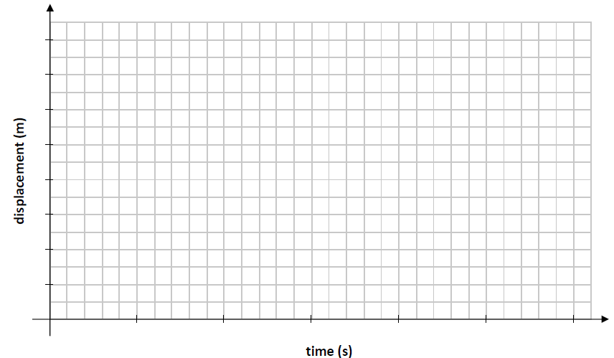

(b)

A project manager is responsible for maintaining a portion of road. The maintenance work is carried out in four stages. For each stage, the manager has a number of options regarding how to complete the work and which sub‐contractors to use.

The options available to the manager may be modelled as a network. The options are represented by edges, where the weight of the edge represents the cost of that option in thousands of euros. Some of the weights are negative because of discounts offered by sub‐contractors. The manager wishes to choose the optimal policy for maintaining the road, i.e. the cheapest overall plan.

The nodes 𝑋 and 𝑌 represent the initial and final states of the decision problem. Each of the other nodes represents a possible state of the decision problem.
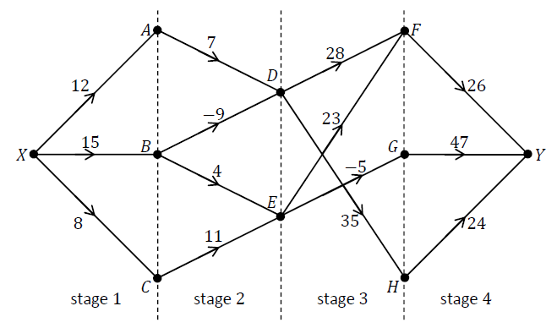

Calculate the plan which minimises the cost of maintaining the road. Relevant supporting work must be shown.

2023 Deferred Question 7

A solid can be modelled as a two‐dimensional lattice of identical particles of mass 𝑚. A particle of the solid may be moved temporarily out of its position but it is quickly returned to that position by the forces that hold the solid together.
An incoming particle 𝑃 of mass 2𝑚, moving with speed 𝑢, collides obliquely with particle 𝑄 which is at rest on the outer surface of the solid. The line joining the centres of the particles at the point of impact is along the 𝚤⃗ axis.
Before the collision, the direction of 𝑃 makes an angle 𝜃 with the 𝚤⃗ axis.

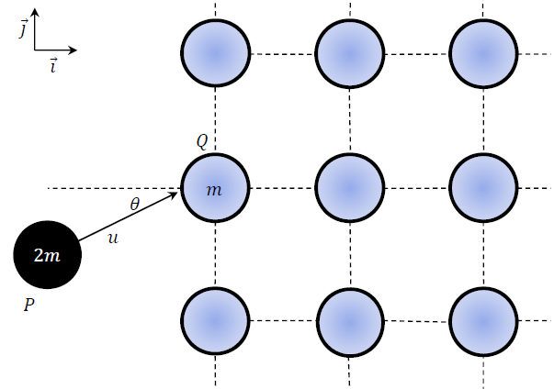

After the collision the direction of 𝑃 has turned through an angle 𝜃, such that it now makes an angle 2𝜃 with the 𝚤⃗ axis.
The coefficient of restitution for the collision is $\frac{2}{3}$.
- Show that tan 𝜃 = $\frac{1}{3}$

- Calculate the 𝚤⃗ and 𝚥⃗ components of the velocity of 𝑄 immediately after the collision in terms of 𝑢.

After the collision 𝑄 experiences a restoring force 𝐹 which is proportional to 𝑥, the displacement of 𝑄 from its initial position, where 𝑘 is the constant of proportionality. (That is, the restoring force may be modelled as being equivalent to the restoring force exerted on a particle by a spring of spring constant 𝑘 stretched through displacement 𝑥.)
- Derive an expression for the work done when 𝑄 moves through displacement 𝑥.

- Find the maximum displacement of 𝑄 from its initial position in terms of 𝑚, 𝑘 and 𝑢.

2023 Deferred Question 8

Two rectangular blocks 𝐴 and 𝐵, of mass 5 kg and 10 kg, rest on two sides of fixed triangular wedge 𝑋𝑌𝑍, with side 𝑌𝑍 lying on the horizontal ground, as shown in the diagram. The blocks are connected by a light inextensible string passing over a smooth pulley at 𝑋.
The edge of block 𝐵 is a distance of 0.4 m from the ground along side 𝑋𝑍. The angles of inclination of sides 𝑌𝑋 and 𝑍𝑋 with the horizontal ground are 40° and 55° respectively.

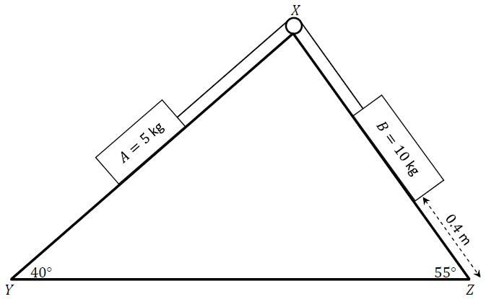

𝜇₁, the coefficient of friction between side 𝑌𝑋 and block 𝐴, is $\frac{1}{8}$.

𝜇₂, the coefficient of friction between side 𝑍𝑋 and block 𝐵, is $\frac{1}{5}$

The wedge does not move when the system is released from rest.
- Show, on separate diagrams, the forces acting on blocks 𝐴 and 𝐵 while they are moving.
- Calculate the common acceleration of blocks 𝐴 and 𝐵 and the tension in the string.

- Block 𝐵 hits the ground and does not rebound.
Calculate the speed of block 𝐵 when it touches the ground.

- After block 𝐵 hits the ground, block 𝐴 continues to move up side 𝑌𝑋.
Calculate the new acceleration of block 𝐴 as it continues to move up side 𝑌𝑋.

- Calculate the total displacement of block 𝐴 from its initial position when it is at its greatest height.

2023 Deferred Question 9

The diagram below shows the scheduling network for a project to construct a stage for a music performance. The network provides some information about the relationships between the thirteen activities that have to be completed in the project.
The edges of the network represent these activities and are labelled with the letters 𝐴 to 𝑀.
The letters used to label the edges should not be taken as representing the order in which the activities happen.
The nodes of the network represent events or points in time during the project. The source node is the time when the project begins and the sink node is the time when the project ends.

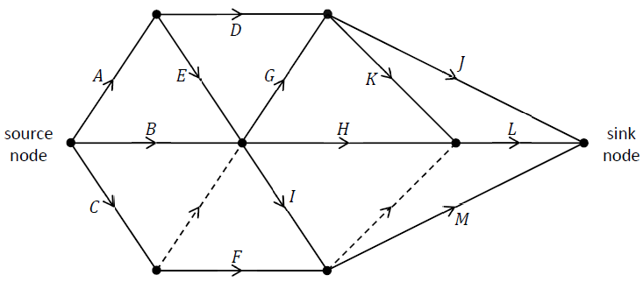

- Explain the significance of the edges represented by dotted lines.

- Complete the table below by listing, for each activity, the other activities on which it depends directly. That is, for each activity 𝑋 ∈ {𝐴, 𝐵, 𝐶, … , 𝑀}, write the smallest possible list of other activities which need to be completed before activity 𝑋 can begin.

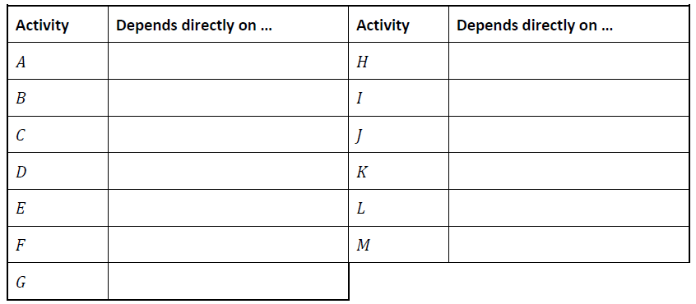

- The time, in hours, to complete each of the activities is represented by the number in brackets.
Calculate the early time and the late time for each event.

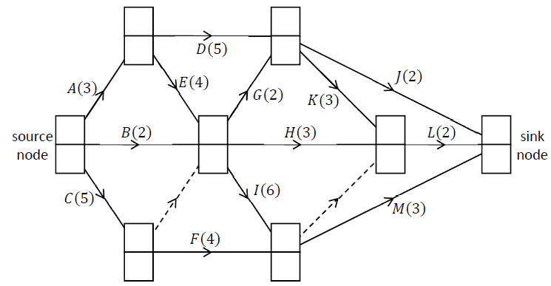
Complete the diagram below by writing the early time (upper box) and late time (lower box) at the node representing each event.

- Write down the critical path(s) for the network.

- Calculate the minimum time needed to complete the project.
- If activity 𝐷 takes 7 hours instead of 5 hours, what effect will this have on the critical path(s) and the time it takes to complete the project? Explain your answer.
- If activity 𝐽 takes 7 hours instead of 2 hours, what effect will this have on the critical path(s) and the time taken to complete the project? Explain your answer.

2023 Deferred Question 10

A smooth cylinder of radius 1.5 m lies on its side in a fixed position on horizontal ground.
A diagram of a circular cross‐section of the cylinder is shown below. The point of contact of the cylinder with the ground is fixed at point 𝑃.
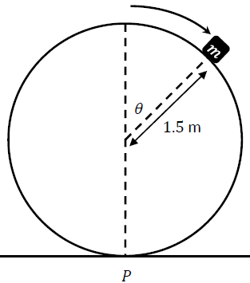
A small object of mass 𝑚 rests on the highest point of the cylinder, vertically above 𝑃. The object is slightly disturbed from rest so that it begins to slide down the cylinder. As it slides it makes an angle 𝜃 with the vertical, as shown in the diagram.

A student wishes to model the initial motion of the object as motion in a vertical circle.
- Outline the assumptions made by the student’s model.
- Calculate the value of 𝜃 when the object leaves the surface of the cylinder.
- Calculate the velocity of the object when it leaves the surface of the cylinder.

The student models the motion of the object after it leaves the surface of the cylinder as projectile motion in a uniform gravitational field.
- Calculate the time between when the object leaves the surface of the cylinder and when it lands on the ground.

- Calculate the horizontal distance between point 𝑃 and the point where the object lands on the ground.

